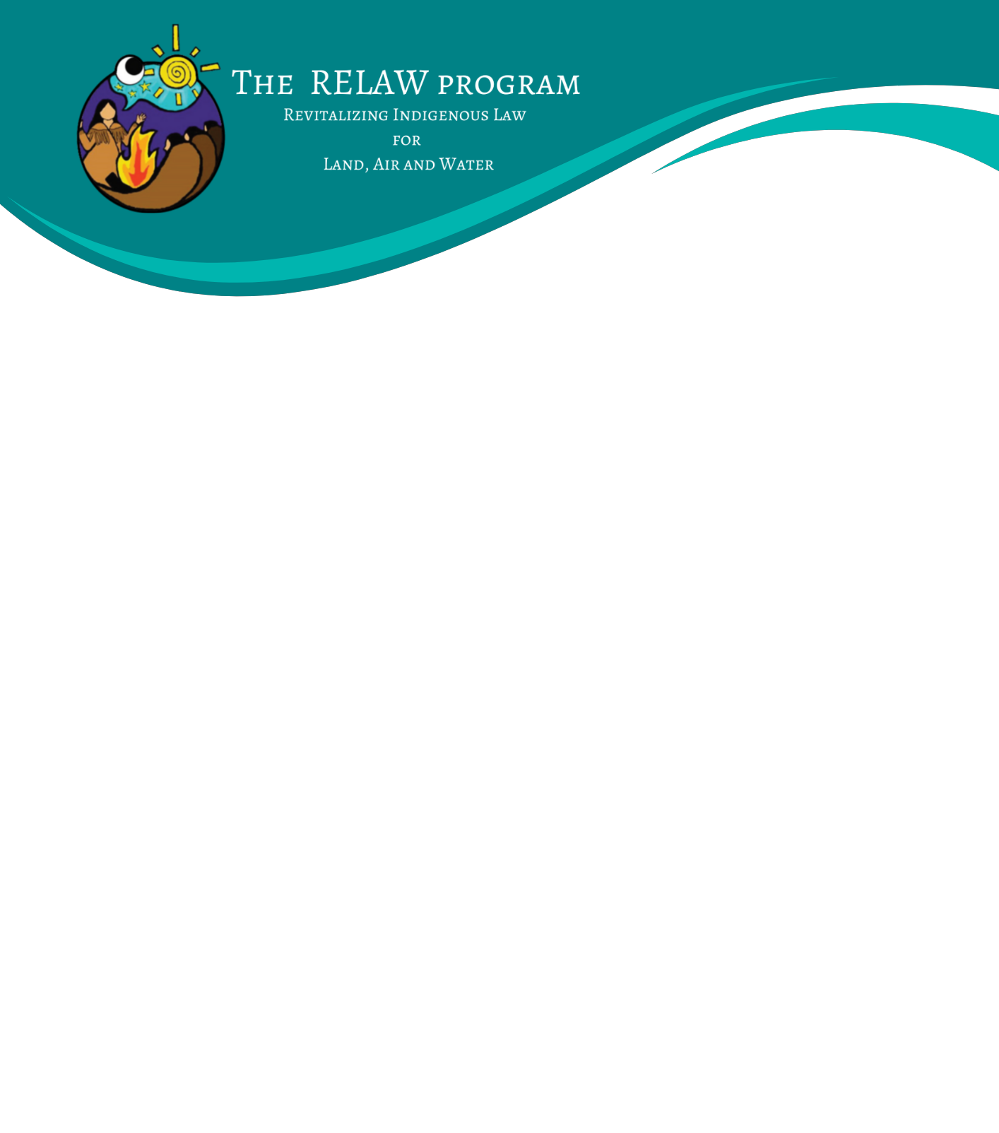

INDIVIDUAL RELAW CO-LEARNERS: EXPRESSION OF INTEREST
We are currently accepting Expressions of Interest to our RELAW Co-learning Program 2023-24 from individuals who wish to learn alongside other like-minded people of approaches and methods of researching, applying and enforcing Indigenous laws. The RELAW Co-learning Program is expected to run from November 2023 – May 2024 with three retreats (two in-person, one online):
- RELAW Retreat 1: Indigenous Law in Story – November 14-17, 2023 at Spirit Ridge Resort, Osoyoos BC
- RELAW Retreat 2: Indigenous Law in Dialogue – February 20-22, 2024 – Zoom half-days
- RELAW Retreat 3: Indigenous Law in Action – May 2024 (4 days) – location TBD

For more details see this Co-learning Program Backgrounder.
Or visit: https://www.wcel.org/background-relaw-co-learning-program.
Indigenous nations or organizations may nominate community members, employees or others with an ongoing, close relationship to the community, to participate in the RELAW Co-learning Program.
Expenses covered for the RELAW co-learning retreats include materials, program content, accommodations and meals. Travel to and from the retreat location is the responsibility of the nominating nation or individual co-learner. Stipends may be available to assist with travel costs if your nation (or the nation you work for) is not able to cover this cost.
To apply, please complete the form below and submit to admin@wcel.org with subject line “RELAW Co-learning Program 2023-24”. Space is limited and first consideration will be given to applications received by September 27th, 2023.

The RELAW Co-learning Program is intended to bring together people who are working with their nation to revitalize, apply and enforce their laws. We strive to create a safe environment for our co-learners. We will call your references, and if you are accepted, we will ask you to agree to our “RELAW protocols” that call for respect, listening and sharing space with others in a good way.

Name:
Your nation, if known:
Position & Contact information (email and phone):
- Please tell us why you’re interested in participating in the RELAW co-learning program and how your participation will help contribute to revitalization of Indigenous law for your nation (minimum one paragraph).

- Please describe themes or topics you are most interested in learning about, if any.

- Is there support you need to make the in-person retreats accessible to you?
- For example, other requests or needs related to audio, visuals, food, wheelchair and other physical/mobility-related access, bathrooms, scent & chemicals, lighting or sound, time, language, quiet space, spiritual/religious time/space, transportation or other identity-related considerations.

__________________________________________________________
Applicant signature

Reference name from your Nation/the Nation you are working with to confirm nomination:

________________________________________ __________________________________________
Name Role/Relationship

________________________________________ __________________________________________
Phone Number Email

*We will reach out to them by email and/or phone in mid-late September 2023*
If you are interested in participating and it is not possible for your nation to nominate you, please offer a brief explanation.

If you have any questions, please contact: Maxine Matilpi, RELAW Program Lead at maxine_matilpi@wcel.org

